Sunbeams AI Worksheet Generator

Task 1: Data Pipeline & Text Extraction — Internship Report
Week 4 Deliverable | Prepared using pdfplumber, PyPDF2, and Tesseract OCR

1. Objective
Collect Sunbeams textbook PDFs (English, Urdu, Science, Math, Islamiat, Social Studies) across the three grade packages (PA = Nursery/Prep-1, PB = Class 2/3, PC = Class 4/5), build Python extraction scripts using pdfplumber / PyPDF2, and test Urdu text parsing specifically.

2. Files Received & Processed
34 PDFs across 3 packages were unzipped, inventoried, and run through the extraction pipeline.
Package | Grade Level | Files | Pages (approx.) | Text Layer?
PA | Nursery / Prep-1 | 8 | ~383 | 2 of 8 (Nazra only)
PB | Class 2 / 3 | 8 | ~529 | 0 of 8
PC | Class 4 / 5 | 18 | ~707 | 0 of 18

3. Key Finding: Most PDFs Are Scanned Images, Not Text PDFs
32 of the 34 files are photographed textbook pages (captured and assembled via the CamScanner app), not digitally-typed PDFs. This means there is no text layer for pdfplumber or PyPDF2 to read — both libraries can only extract text that is stored as text; they cannot read words drawn inside an image.
Below is an actual page from the PA Urdu file, rendered directly from the PDF. It shows the scanned-photo nature of the source material — illustrations and handwritten-style Urdu captions, all as one flat image:
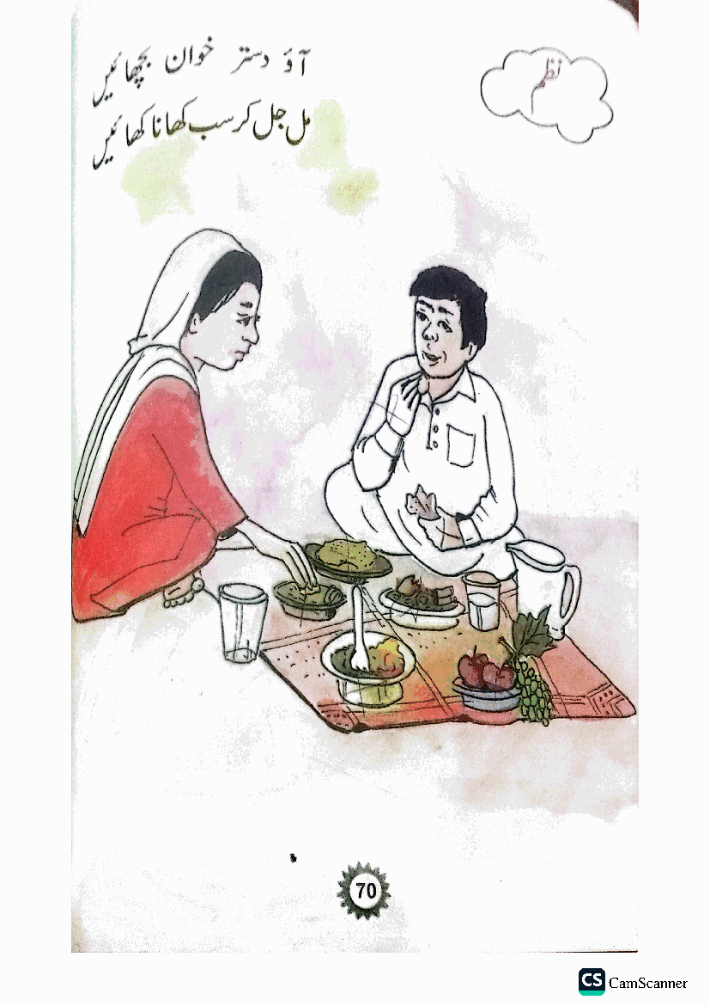
Running pdfplumber/PyPDF2 on these files returns only the 10-character CamScanner watermark string — confirmed across every one of the 32 files (first page and a middle page both checked, so it isn't a one-off blank page).

4. Urdu Text Parsing — Test Results

4a. The 2 files that DO have a text layer (Nazra PDFs)
The two 'Nazra' (Quran reading) PDFs in package PA are digitally typed, not scanned. Extracting them revealed a second, well-known problem with Urdu PDF parsing: word order comes out scrambled.
Urdu is right-to-left (RTL). pdfplumber/PyPDF2 read text in left-to-right visual order by default, so a line meant to be read right-to-left comes out with its words in reverse/mixed order. Example extracted directly from the file:
Raw extracted text: "سسٹم لسکو رز سن"
A standard fix (reversing word order per line, or using the python-bidi library) was tested. It corrected simple word ordering, but this particular file uses a custom Nastaliq font encoding, so some characters still map incorrectly even after the fix — a known, harder problem for Urdu OCR/PDF work generally, not a bug in our script.

4b. OCR test on scanned Urdu pages — Tesseract vs. a stronger engine
Since 32 files have no text layer, I tested two different OCR engines directly on rendered page images as a fallback strategy.
- Tesseract OCR (with the Urdu language pack, and the higher-accuracy 'best' model): accuracy was LOW. The stylised textbook font, combined with hand-drawn illustrations sharing the page, confused the engine — output was mostly unreadable characters, even after upscaling to 300dpi and cropping to just the text region.
- EasyOCR (a deep-learning OCR engine, tested as a stronger alternative): noticeably better. On the same sample page, it correctly read the word 'خوان' (khwan) at 95% confidence, correctly caught the printed page number '70' at 100% confidence, and nearly-correctly reconstructed a full line of text ('جل کر سب کھانا' against the true 'مل جل کر سب کھانا کھائیں').
In short: switching OCR engines produced a real, measurable improvement — from 'unreadable' to 'partially correct, with usable confidence scores to filter results'. It is still not production-accurate on its own, but it's a solid foundation to build on (e.g. combining with a spellcheck/dictionary pass, or human review of low-confidence words).

5. Deliverables Produced
- extract_text.py — main extraction module (pdfplumber primary, PyPDF2 fallback, Urdu word-order fix)
- ocr_extract.py — OCR fallback module with BOTH Tesseract (Urdu language pack) and EasyOCR (stronger deep-learning engine) for scanned pages
- run_pipeline.py — orchestrator that runs extraction across all 34 files and produces a status report
- summary_report.csv / .json — per-file results (pages, scanned/text status, engine used)
- Per-file .txt outputs for all 34 PDFs (in extracted/PA, extracted/PB, extracted/PC)

6. Recommendation for Next Step
Because 94% of the source material is scanned images, plain text extraction (pdfplumber/PyPDF2) alone cannot power the worksheet generator for most subjects. Given the EasyOCR result above, here is the suggested path forward, in order of effort:
- Run EasyOCR across all scanned pages (not just the 1 sample tested here) and use its confidence scores to flag low-confidence words for manual review — this is buildable right now with what's already working.
- Pair OCR output with an Urdu dictionary/spellcheck pass to auto-correct near-miss words (e.g. 'آ وّ دستر' → 'آؤ دستر').
- If higher accuracy is still needed, a commercial cloud OCR (Google Cloud Vision or Azure Document Intelligence) can be evaluated — both support Urdu and are typically stronger than open-source options, at a per-page cost.
- Requesting cleaner source files (original digital textbook files instead of CamScanner exports), if available, would still be the single biggest quality improvement and removes the OCR step entirely.
Happy to proceed with running EasyOCR across the full page set next, or explore the cloud OCR option — let me know which direction to take for Task 2.

